**Function Parameter Passing and Return Assignments**

**Refer the code below and find the issue.**

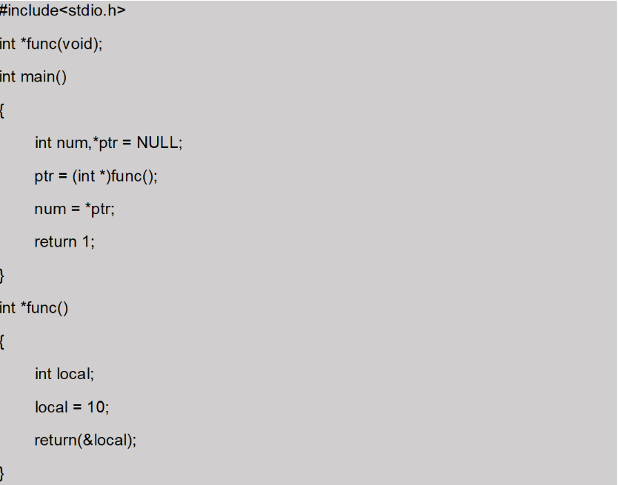

**In above code is there a way(s) to return local variable address to caller?**

The issue with the code is that it attempts to return the address of a local variable from the function func():

We cannot return the address of a local variable from a function. Instead, you have a few options:

1. Return a dynamically allocated memory address (heap memory).
2. Pass a pointer to the function and have the function modify it.

In the below version code , we allocate memory dynamically using malloc and return the pointer to the caller. The caller is then responsible for freeing the memory when it is no longer needed.

**2. Write a program with a function read_extract_characters() to read a string (of max length 50 characters) from user, extract the characters at odd indices, store in an other array and return to the call. Caller should be able to read and display the extracted string.**

**[Note : do not return a local variable in function to caller],**

**ANS:**

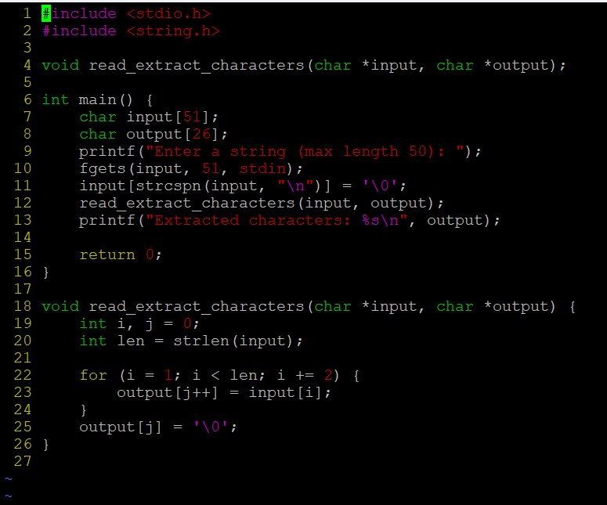

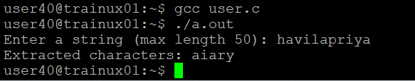

**3. Write below functions to extract and return the required inputs from an email id string of max length 80 characters. Program should be able to detect an invalid email id too based on following validations. Also value returned should be in scope and accessible in caller.**

a. valid email id will have username, host and domain name (as .com/.edu)

Functions:

